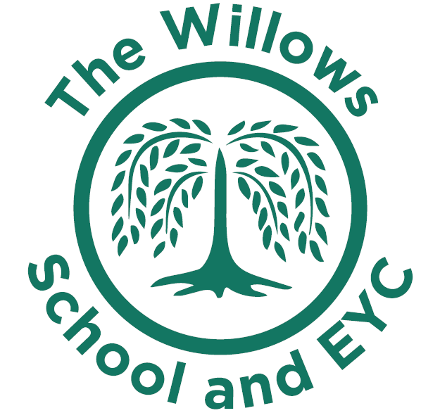
Music development plan summary:
The Willows First School and Early Year Centre

Overview
Detail | Information
Academic year that this summary covers | 2024-2025
Date this summary was published | 5th September 2024
Date this summary will be reviewed | July 2024
Name of the school music lead | Gemma Hawkins
Name of school leadership team member with responsibility for music (if different) | Jo Orbell
Name of local music hub | Milton Keynes
Name of other music education organisation(s) (if partnership in place)

This is a summary of how our school delivers music education to all our pupils across three areas – curriculum music, co-curricular provision and musical experiences – and what changes we are planning in future years. This information is to help pupils and parents or carers understand what our school offers and who we work with to support our pupils’ music education.

Part A: Curriculum music
In our school Music is taught throughout EYFS and KS1. We use the Charanga scheme to enhance experiences for all children during their music lessons. Music is taught in classes for 45minutes per week and then in singing assembly each week which lasts for 30minutes. Throughout the year there are performances which children take part in both vocally and playing musical instruments. These performances require audiences both inside and outside of the school community.
As a school we have a focus music genre each term over a 2 year programme and children learn about these genres and are exposed to the genre during celebration assemblies each week.
We work with Milton Keynes hub to provide additional performance opportunities for our children and within our cluster group working with other schools and using expertise from our local Secondary school.
Our Music Curriculum Intent

At The Willows School it is our intent that we make music an enjoyable, rich and stimulating learning experience. The desired learning intentions from the 2014 National Curriculum for primary music outlined in the programmes of study can be met practically through Musical School which is a scheme we use developed and provided by Charanga. This supports our non-specialist staff to plan and teach high quality music sessions.
Through the Musical School programme the children develop their understanding, make musical judgements, apply their new learning, develop their aural memory, express themselves physically, emotionally and through discussion and create their own musical ideas. The wide range of core resources have been developed specifically to motivate and capture each individual’s personal interest.
The children not only learn about music; they become musicians who are able to share and perform using their new skills. Each term the school has a new music genre to focus upon and this is over a two year cycle.
We enable children to participate in a variety of musical experiences through which we aim to build a range of skills and understanding in musicality

EYFS

Music threads through all areas of learning and development. Music can be a way of exploring, communicating and responding to experience. Our pupils will use what they have learnt about music in original ways, thinking about uses and purposes. They represent their own ideas, thoughts and feelings through music, dance, role play and stories. Adults facilitate singing and music learning and children explore the sounds of instruments in both adult lead and child-initiated learning.
Key stage 1

Our pupils will learn that music is a universal language that embodies one of the highest forms of creativity. They will be inspired and engaged by music education. Music lessons will engage and inspire pupils to develop a love of music and develop their talent as musicians, and in turn increase their self-confidence, creativity and sense of achievement.

Part B: Extra-curricular music and Musical experiences
At our school we encourage all children’s talents by signposting to additional groups which happen beyond the school gates and celebrating children’s talents within school assemblies.
As a school we have a signing club and a musical theatre club over the year which children can access and then perform to families at the end of each term. These clubs are open to children from 4-7 years old and cost £15 per 5 weeks.
This is about opportunities for pupils to sing and play music, outside of lesson time, including choirs, ensembles and bands, and how pupils can make progress in music beyond the core curriculum.
Our children have had opportunity to perform as a choir at local events and often visit care homes at Christmas and sing to a variety of audiences. The children also have an opportunity throughout the year to visit the theatre in Milton Keynes, or watch a theatre production at school and visit other schools to watch performances. Theatre trips are subsidised by the school so that everyone is able to enjoy the experience.

In the future
As a school we hope to be able to introduce specific instrumental lessons which can be subsidised to enable many children to access and learn to play a new instrument.
We will continue to have school performances throughout the year and introduce more assemblies where children can sing to an audience.

