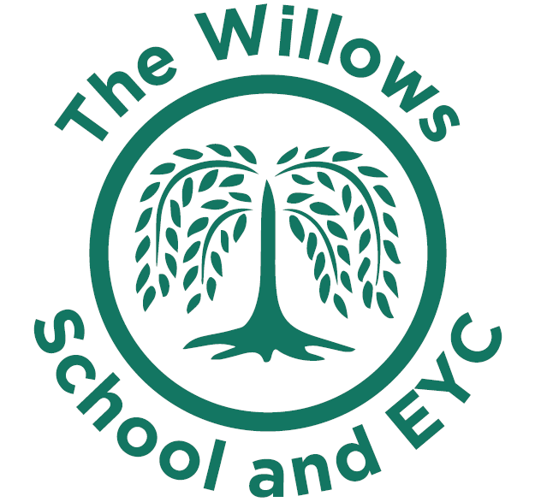
The Willows School and Early Years Centre
Fishermead Boulevard, Fishermead, Milton Keynes MK6
Tel: 01908 528803 Email: office@thewillowseyc.org.uk
Website: www.thewillowseyc.org.uk

To become honest, active citizens
and lifelong learners in a global society
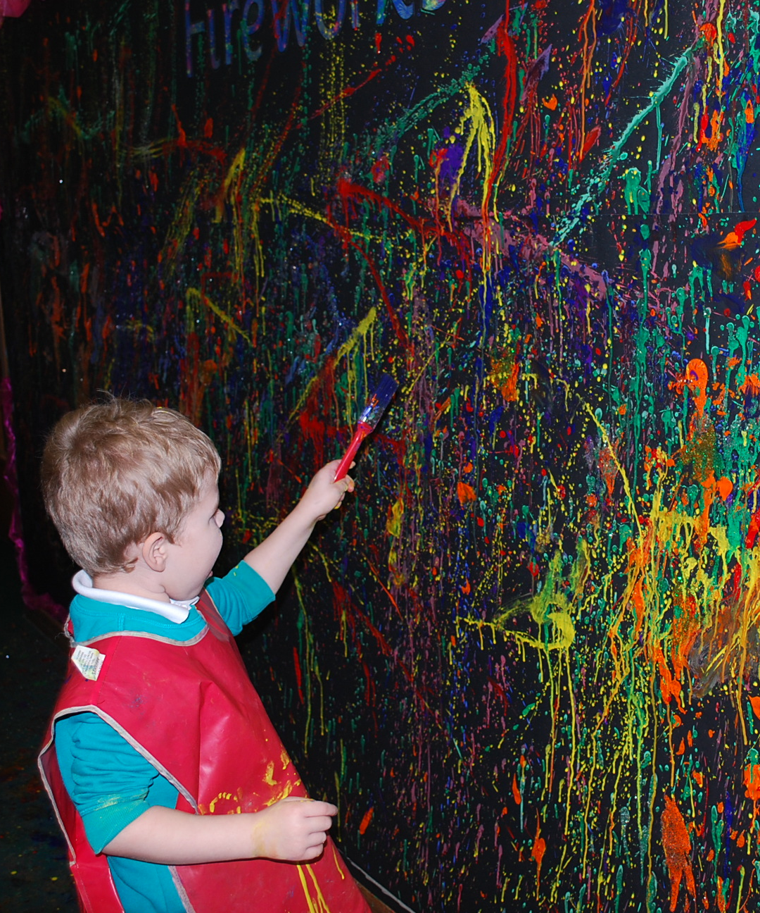
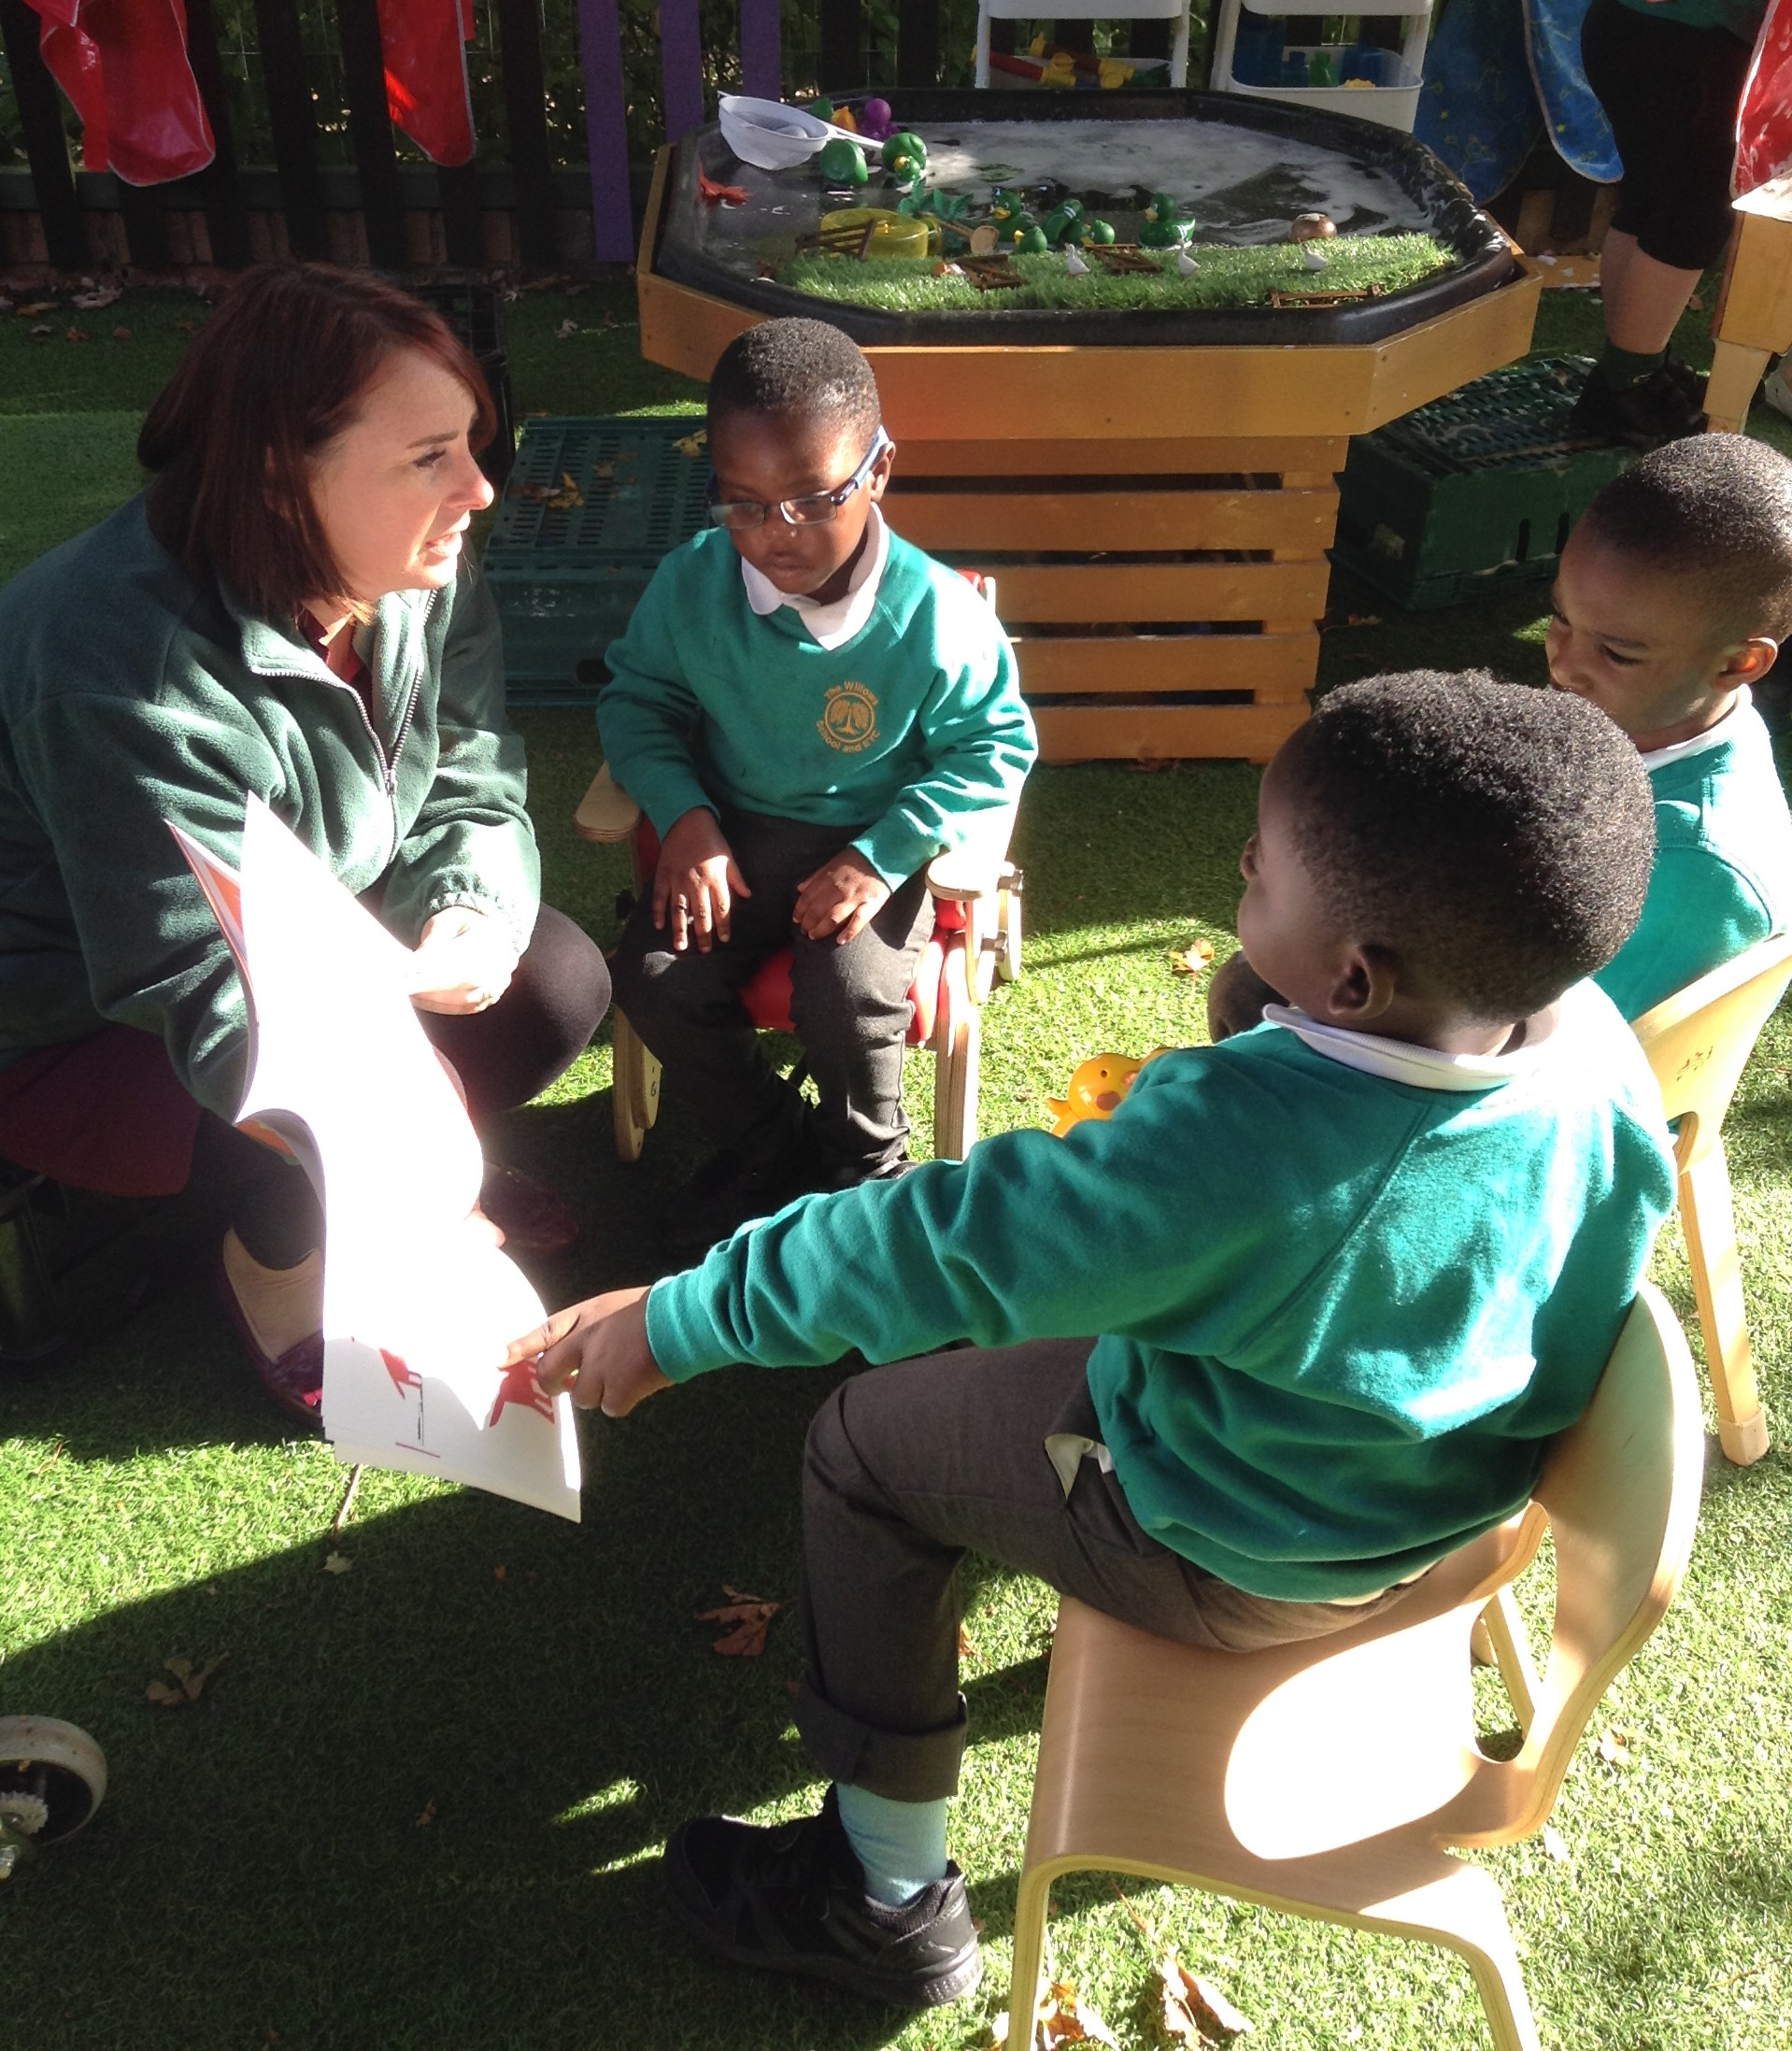

Class Teacher
To start Feb or
as soon as possible after

Maternity Cover until Dec 2025
(Potential to become permanent )
Full time

Are you looking for something new where you can enjoy a challenge with each day being different? Then look no further! The Willows School and Early Years Centre is a thriving Infant School with a nursery (from age 2). Through our culture of supporting the whole family, we work closely with our on-site children’s centre to support children from all backgrounds to make good progress. The school has recently been judged “good” by Ofsted and we are now on our journey to “outstanding”.

We can offer you:
- A supportive leadership team, a friendly workplace, children who want to learn and a chance to make a real difference in the lives of our children.
- An excellent working environment with fantastic opportunities for continuing professional development.
- LGPS pension scheme, access to a free wellbeing app, coffee van visits and a commitment to staff wellbeing.
We are looking for someone who:

- Has a passion for Early years or KS1 teaching and able to inspire lifelong learning.
- Is a creative and dynamic classroom teacher.
- Is able to secure high standards in all areas of the curriculum through the highest expectations of yourself and the children in our school.
- Is imaginative and able to plan relevant cross-curricular learning experiences.
- Is enthusiastic, energetic and willing to be involved in all aspects of school life.

The Willows School is committed to equal opportunities and we encourage applications from applicants from all backgrounds. The post is ubject to an enchanced DBS check

We encourage applicants to look round our school. Visits to the school are welcome - please contact the school office to book a time.
Application packs are available from the school office and our website. All applications must be made using the Milton Keynes Council application form. CVs will not be accepted.

Closing date for applications: 3rd February 2025 @ 12pm
Interviews will be held week commencing 10th February 2025
The Willows School and EYC is committed to safeguarding and promoting the welfare of children and vulnerable adults. All employees are expected to share this commitment, to follow the centre’s safeguarding policies and procedures and to behave appropriately towards children and vulnerable adults at all times, both in work and in their personal lives. References may be taken up prior to interview. An online search will be conducted on shortlisted applicants. The post is exempt from the rehabilitation of offenders Act 1974, (amended 2013 and 2020).

